MH6818 Assignment 1
End-to-End AI Credit Decision System for FBank
Student Name: SRIVASTAVA ABHISHEK
Student ID: G2505156E
Course: MH6818
Link to live app: Live App
Github link : Repo

1. Executive Summary

FBank currently relies on a hybrid of manual review and static credit rules to make unsecured lending decisions. That operating model is increasingly difficult to scale: it slows turnaround time, creates inconsistency across reviewers, makes policy updates hard to operationalize uniformly, and limits the bank's ability to segment risk in an economically disciplined way. This report proposes an end-to-end AI credit decision system that combines predictive modeling, policy overlays, fairness review, deployment design, and governance controls.

The technical prototype was built on a historical labeled dataset of 7,500 applications and applied to 2,500 new applications. The modeling workflow was leakage-safe: the raw dataset was split into train, validation, and test partitions before train-fitted preprocessing was applied. Several candidate models were evaluated, including Logistic Regression, Random Forest, and XGBoost. The final selected model was a threshold-optimized XGBoost classifier with a decision threshold of 0.1019, selected on the validation set to maximize F1-score. That threshold yields a high-recall credit-risk operating stance. On the held-out test set, the final model achieved ROC-AUC 0.6778, precision 0.3454, recall 0.8738, and F1-score 0.4951.

The point 7 decisioning layer translates model probabilities into business decisions. The implemented framework uses the model output as probability of default, applies a fixed loss given default assumption of 45%, treats cleaned current loan amount as exposure at default, and calculates expected loss as:
A
Expected Loss = PD × LGD × EAD
Access to the functional demonstration of the credit evaluation dashboard is provided via:https://amh6818-assignment-1-abhishek-srivastava.streamlit.app/

The framework then routes applications into three business outcomes: recommend, approve, manual review, or recommend reject / escalate. On the 2,500 new applications, the resulting distribution was:

- 727 recommend approve
- 771 manual review
- 1002 recommend reject / escalate

The aggregate modeled expected loss across the new-application portfolio is approximately 92.68 million in the same monetary units as the loan amount field.

Fairness was assessed through a proxy sensitivity review on Home Ownership. This is not a legal fairness certification, but it is an appropriate governance test for a prototype. The measured approval-rate gap is 12.85%, the false-positive-rate gap is 12.13%, and the false-negative-rate gap is 13.60%. An ablation test shows that removing Home Ownership leads to only modest performance changes and slightly improves test-set performance, which supports a more conservative production recommendation.

Overall, the prototype demonstrates that FBank can operationalize a materially better credit decision process than a purely manual or rules-only workflow. However, the solution should be treated as a strong prototype rather than an immediately production-ready credit engine. The very high train performance relative to test performance indicates meaningful model-risk concerns, and the strongest production recommendation is to deploy a more conservative governed version with tighter feature review, improved upstream data controls, and formal monitoring and override management.

2. Business Problem Diagnosis and Motivation to Innovate

FBank's current credit process is described as a hybrid of human review and rule-based assessment. That operating model may be workable at low volumes, but it creates several structural business problems.

First, turnaround time is likely slow and variable. Human review introduces queueing delays, and rules-based systems usually escalate large numbers of borderline cases because they cannot rank risk finely. In unsecured consumer lending, response time matters commercially: slow decisions reduce conversion, frustrate applicants, and limit the bank's ability to compete with digital-first lenders.

Second, decision quality is inconsistent. Static rules may be simple to explain, but they are blunt instruments. They can reject cases that are economically acceptable, approve cases that are risky in combinations not captured by hard-coded rules, and leave too much discretion to individual reviewers in edge cases. Over time, manual overrides and local reviewer habits can create policy drift.

Third, the current process is hard to scale. Growth in application volume increases staffing needs almost linearly when large portions of the flow still require manual review. That makes cost discipline difficult and weakens the business case for portfolio expansion.

Fourth, legacy decisioning has governance limitations of its own. Manual review may feel safer than automation, but it can embed inconsistency, weak auditability, and implicit bias. A modern AI-enabled system, if governed properly, can improve audit trails by making model versions, thresholds, overrides, and review reasons explicit.

The motivation for innovation is therefore not only better prediction. It is also better operating leverage, more consistent policy application, more disciplined risk segmentation, and a stronger connection between credit decisions and economic value. For FBank, the AI credit decision system should support four business outcomes:

- faster straight-through processing for clearly low-risk applications
- more targeted manual review for borderline or policy-sensitive cases
- tighter control of high-risk approvals and expected-loss exposure
- better governance evidence for regulators, risk managers, and senior management

This report treats the proposed system as a business process redesign supported by machine learning, rather than as a stand-alone predictive model.

3. Dataset Overview and Key Assumptions

The solution uses two datasets:

- credit-default-data.csv: 7,500 historical applications with labels for model training and evaluation
- new-applications.csv: 2,500 unlabeled applications for forward-looking scoring and business decisioning

The historical default rate in the labeled sample is 28.17%, which means the dataset is imbalanced but not extremely rare-event. This is important because model selection and threshold choice should pay close attention to recall and precision, not just overall ranking quality.

The feature set contains borrower stability, affordability, leverage, bureau-quality, and product-intent information, including variables such as annual income, credit score, job tenure, current balances, credit problems, purpose, and term. Several fields are economically meaningful but operationally imperfect, so the report distinguishes between borrower-risk signal and process-quality signal.

This report also makes several explicit assumptions, because the assignment data does not contain all the inputs needed for a full bank profitability model:

1. The model's output is interpreted as probability of default, not probability of approval.
2. Exposure at default is approximated using the cleaned Current Loan Amount.
3. Loss given default is fixed at 45% for all applications.
4. Expected loss is therefore modeled as PD × LGD × EAD.
5. Revenue variables such as interest margin, pricing, fees, funding cost, and collection cost are not available, so the report proposes an economic value methodology rather than a fully realized profit model.
6. Home Ownership is treated as a proxy fairness review field for internal governance, not as a statement of legal protected-class fairness.

4. Data Preparation and Quality Issues

The dataset contains several material quality issues that directly affect both modeling and governance. These are not minor cleaning details; they shape the business interpretation of the solution.

The historical training dataset contains the following issues:

- Annual Income missing: 1,557
- Credit Score missing: 1,557
- Years in current job missing: 371
- Months since last delinquent missing: 4,081
- Bankruptcies missing: 14
- Current Loan Amount = 99,999,999 placeholder: 870
- Credit Score > 850: 400
- Have Mortgage label inconsistencies: 12

The new-application dataset shows the same pattern of operational imperfection:

- Annual Income missing: 513
- Credit Score missing: 513
- Years in current job missing: 86
- Months since last delinquent missing: 1,358
- Bankruptcies missing: 3

These issues matter in business terms for three reasons.

First, they affect predictive performance. Missing income and credit score fields reduce the quality of affordability and bureau-risk signals. If ignored, these gaps would either leak bias through ad hoc imputation or force the model to confuse "no data" with "safe data."

Second, they affect governance. A placeholder such as 99,999,999 in current loan amount is not a normal borrower value. It likely reflects an upstream process behavior, system default, or special operational path. If that field becomes highly predictive, the model may be learning process behavior rather than underlying creditworthiness.

Third, they affect production readiness. Data quality issues that are manageable in a prototype should be treated as operational risks in a production design.

The implemented preparation logic addresses these problems in a transparent way:

- Home Ownership is normalized so Have Mortgage is mapped to Home Mortgage.
- Credit scores above 850 are rescaled by dividing by 10.
- Placeholder Current Loan Amount = 99,999,999 is masked from the numeric amount and preserved via a dedicated flag.
- Text job tenure is converted into a numeric job_tenure_years feature.
- Missingness flags are created for income, credit score, job tenure, and delinquency history.
- Median imputation is applied to selected numeric fields using train-only statistics.
- Three economically meaningful engineered features are created:
- monthly_dti
- credit_utilization_proxy
- loan_to_income_ratio

This preparation strategy is appropriate because it preserves business meaning. Rather than pretending the data is clean, it explicitly encodes missingness and process artifacts. That is more defensible in both a model-risk and reporting context.
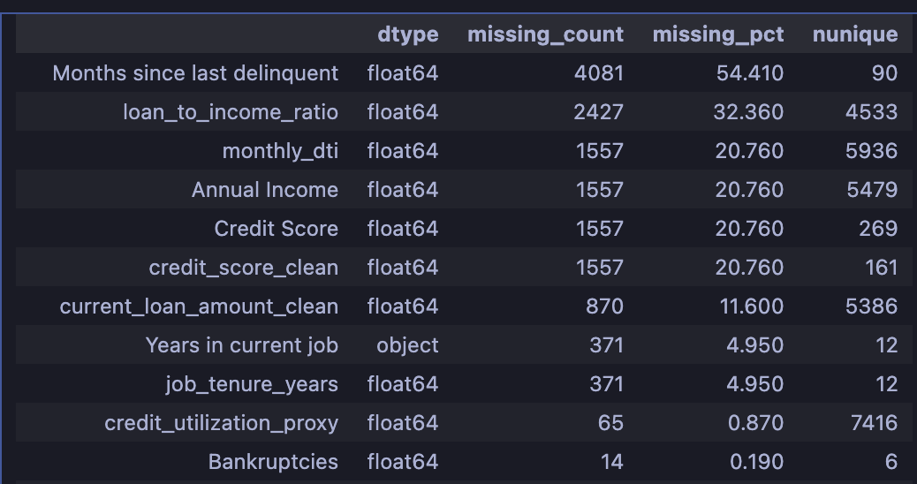
Data Quality Audit Summary

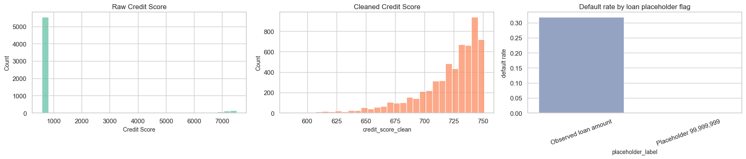

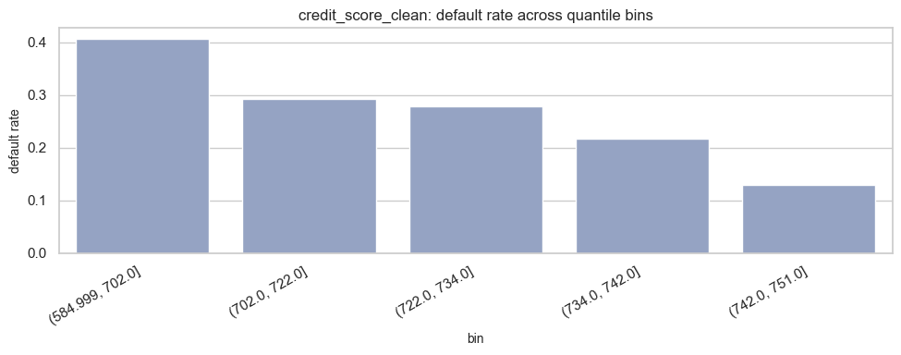

5. Predictive Modelling Approach

The modeling workflow is intentionally leakage-safe. The raw dataset is split before any train-fitted preprocessing is applied, which prevents information from the validation or test sets from influencing imputation statistics or one-hot encoded feature structure.

The split design is:

- Train: 5,250
- Validation: 1,125
- Test: 1,125

The validation set is used for development choices such as model comparison and threshold selection, while the test set is reserved for final held-out reporting.

Three model families were evaluated:

- Logistic Regression
- Random Forest
- XGBoost

This set gives a sensible modeling progression. Logistic Regression provides a strong interpretable baseline. Random Forest captures nonlinearities and interactions with limited preprocessing burden. XGBoost is a strong modern tree-ensemble benchmark and is often effective in structured credit data.

Model evaluation uses metrics that match the business problem:

- Recall: important because missed defaulters are costly. A false negative means the bank may approve a risky borrower.
- Precision: important because false positives mean unnecessarily rejecting or escalating creditworthy applicants, hurting revenue and customer experience.
- F1-score: required by the assignment and useful because it balances precision and recall.
- ROC-AUC: useful for ranking quality and for comparing how well models separate risky from safer cases before the operating threshold is chosen.

The most important business decision in this project is not only which model to use, but also where to set the operating threshold. A default threshold of 0.50 is rarely optimal in lending. In this prototype, the threshold was selected on the validation set by maximizing F1-score on the precision-recall curve. That data-driven threshold optimization produces a higher-recall risk posture that is directionally aligned with credit-loss prevention, but it is not the same as a threshold calibrated directly from explicit business costs or risk-appetite targets.

Table 1 summarizes the validation-set comparison that most directly motivated the final selection.

Model | Validation ROC-AUC | Validation Precision | Validation Recall | Validation F1
Logistic Regression | 0.7200 | 0.5207 | 0.1987 | 0.2877
Random Forest | 0.7015 | 0.5124 | 0.1956 | 0.2831
XGBoost Baseline | 0.7296 | 0.5682 | 0.1577 | 0.2469
XGBoost Threshold Optimized | 0.6835 | 0.3611 | 0.8738 | 0.5111

This comparison shows an important credit-risk trade-off. At default thresholds, the models deliver reasonable precision but very weak recall. That is undesirable if FBank's primary concern is controlling bad approvals. The threshold-optimized XGBoost model sacrifices some precision to capture far more defaulters and materially improve F1-score, making it more suitable as a decision-support engine.

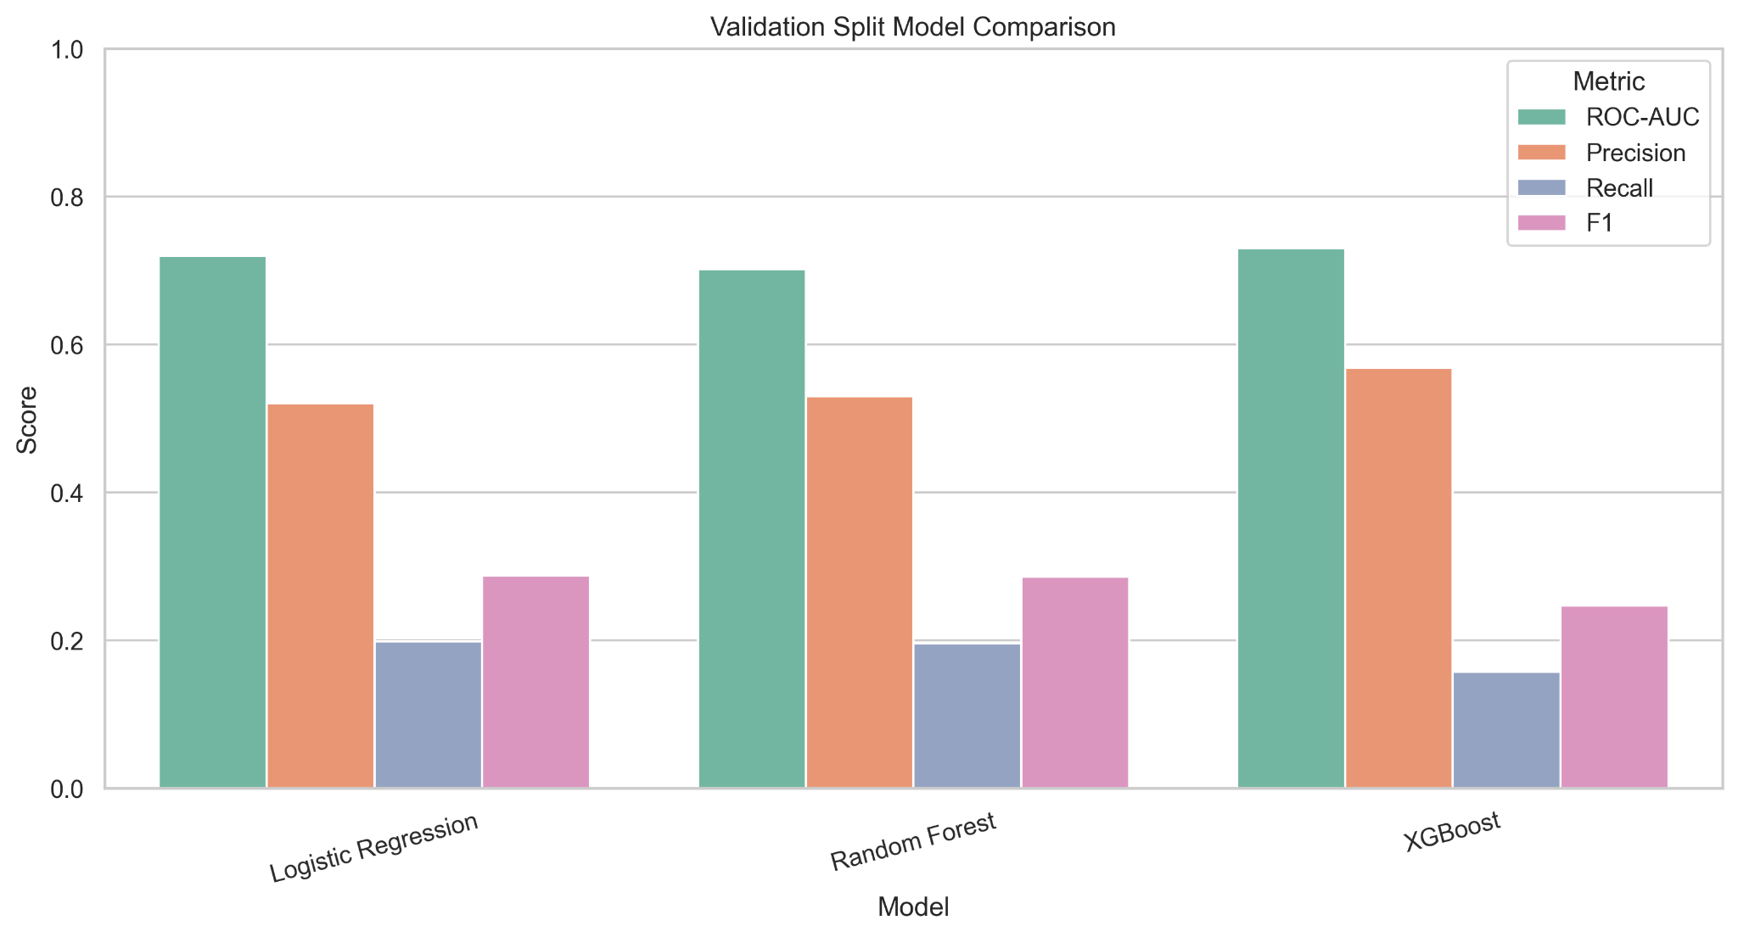

6. Model Evaluation and Final Model Selection

The final selected model is the threshold-optimized XGBoost workflow saved in the codebase with a threshold of 0.1019. This low threshold was selected through validation-set F1 optimization rather than the default 0.50 probability cutoff. The resulting operating point is more risk-sensitive and materially increases recall. The final train, validation, and test performance is:

Split | Samples | ROC-AUC | Precision | Recall | F1
Train | 5,250 | 0.9999 | 0.5130 | 1.0000 | 0.6781
Validation | 1,125 | 0.6835 | 0.3611 | 0.8738 | 0.5111
Test | 1,125 | 0.6778 | 0.3454 | 0.8738 | 0.4951

Two observations are important.

First, the validation and test performance are close. That is a useful sign because it suggests the final development choices did not collapse on the held-out set. In other words, the prototype's out-of-sample behavior is at least stable between validation and test.

Second, the train-test gap is very large. A training ROC-AUC of 0.9999 compared with a test ROC-AUC of 0.6778 is a clear model-risk warning. The model is learning patterns that do not generalize fully.

The held-out test confusion matrix is:
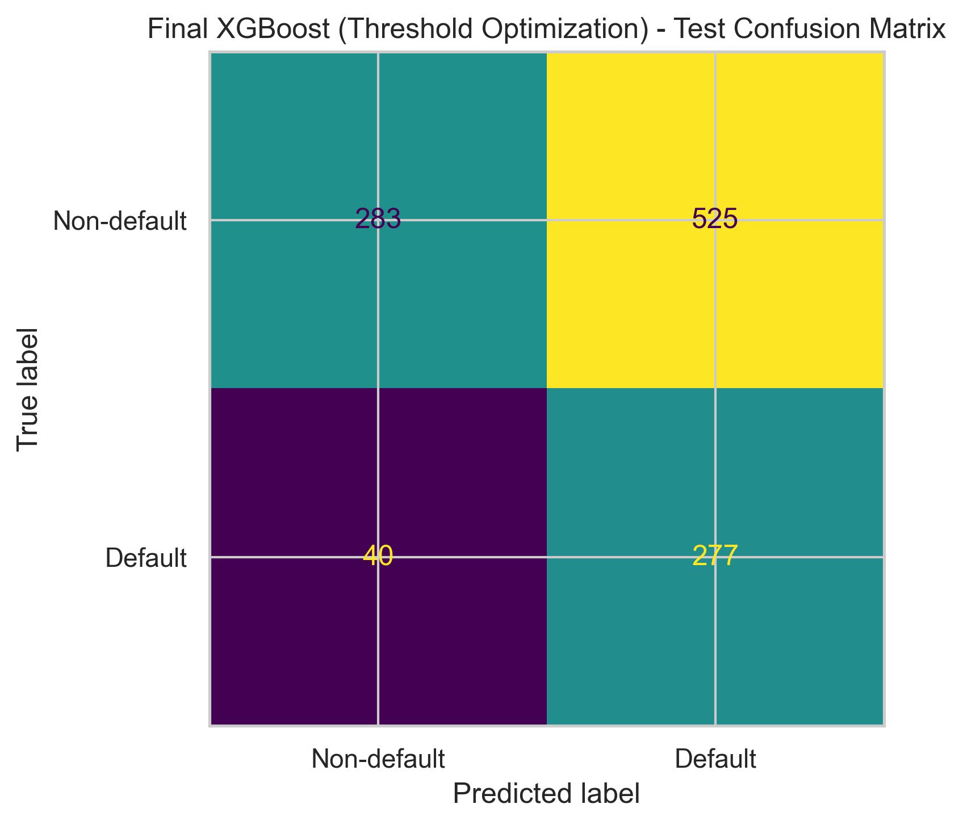
This confusion matrix confirms the chosen operating stance. The number of false negatives is deliberately low relative to false positives. In business terms, the model is more willing to inconvenience good borrowers than to miss a likely defaulter. That is a reasonable prototype stance for a bank prioritizing credit-loss containment, but it also means customer-experience and portfolio-growth trade-offs must be actively governed.

Feature interpretation provides both business insight and governance caution. The strongest gain-based feature importances in the saved final model include:

- loan_amount_placeholder_flag (0.3185)
- Term_Long Term (0.0625)
- Purpose_business loan (0.0382)
- Purpose_medical bills (0.0381)
- job_tenure_missing_flag (0.0319)
- Number of Credit Problems (0.0262)
- credit_score_missing_flag (0.0239)
- Tax Liens (0.0239)
- Home Ownership_Own Home (0.0232)
- loan_to_income_ratio (0.0218)

The economic interpretation is intuitive in several places: longer loan term, risky purposes, credit problems, public-record distress, and stretched affordability all signal higher risk.

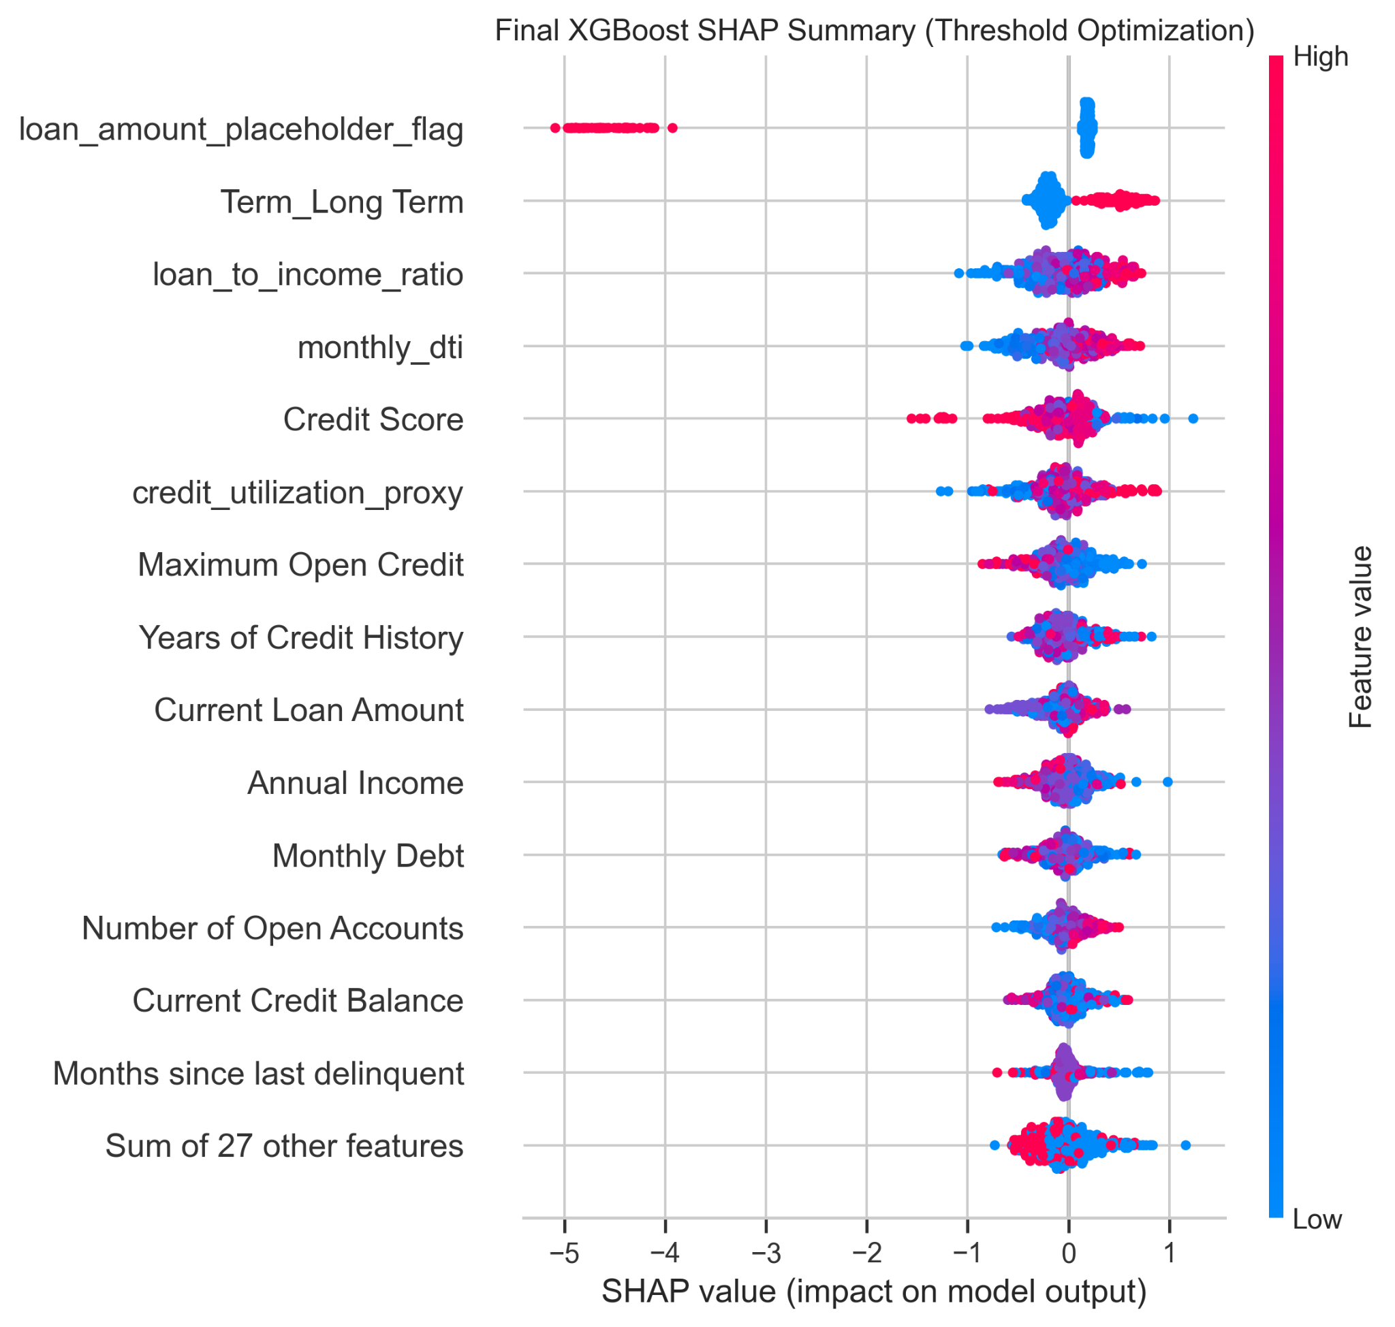

7. Economic Decision Framework for new-applications.csv

The framework begins with the model's predicted default probability. That probability is treated as PD. Exposure at default is approximated using the cleaned current loan amount, and loss given default is fixed at 45%. Expected loss is then calculated as:

Expected Loss = PD × 45% × Cleaned Current Loan Amount

The solution then applies business decision bands:

- Recommend Approve when PD is low
- Manual Review when PD is in the middle band
- Recommend Reject / Escalate when PD is high

The framework also applies policy overlays that reflect practical credit controls:

- very high debt-to-income ratio triggers escalation
- moderately high debt-to-income ratio triggers manual review
- high loan-to-income ratio triggers manual review
- high credit-utilization proxy triggers manual review

These overlays are business-logical because a model probability alone should not fully determine action. Banks frequently keep policy rules around affordability, leverage, and exceptions even when using predictive models.

Applying the framework to the 2,500 new applications produces the following summary:

Decision Band | Application Count | Share of Applications | Average PD | Total EAD | Total Expected Loss
Recommend Approve | 727 | 29.08% | 3.55% | 198,350,020 | 3,225,714.90
Manual Review | 771 | 30.84% | 15.76% | 230,998,900 | 16,452,954.36
Recommend Reject / Escalate | 1002 | 40.08% | 46.32% | 339,129,472 | 73,002,650.08
Overall | 2500 | 100.00% | 24.46% | 768,478,392 | 92,681,319.33

Several business conclusions follow.

First, the reject/escalate share is high. That is consistent with the intentionally risk-sensitive operating threshold and with the strong policy overlay logic. It is acceptable in a prototype focused on loss containment, but FBank should expect commercial pressure to revisit the cutoffs once better pricing and lifetime-value data are available.

Second, the manual-review bucket is large enough to matter operationally. This is actually useful: instead of sending only obvious failures to manual review, the framework isolates a meaningful middle tier where human judgment can be spent on cases with the highest decision value.

Third, expected loss is heavily concentrated in the reject/escalate segment. That concentration is a positive sign for segmentation quality. It suggests the system is routing a disproportionate share of economic risk into the most restrictive decision band.

The important limitation is that this is not a full profitability engine. Because pricing, cost of funds, fee income, and collections data are absent, the design should be described as a simplified risk-based economic decision framework. It is good enough for portfolio triage, review routing, and loss-aware policy discussion.
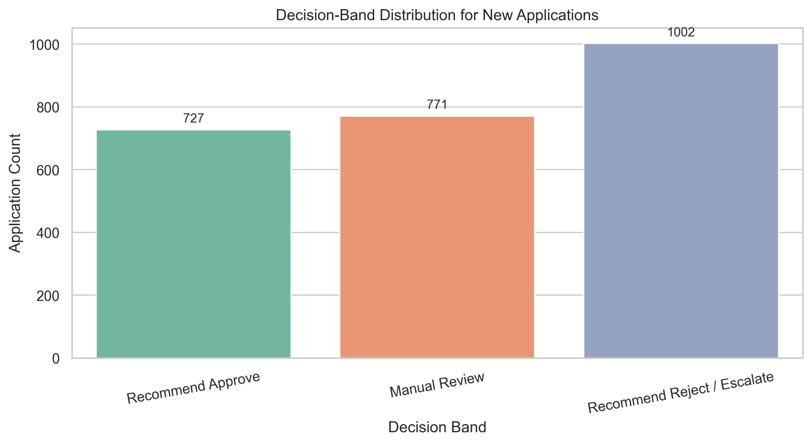

8. Fairness and Bias Assessment

Fairness must be treated explicitly in a credit decision system. In this prototype, the practical fairness question is not whether the model is perfectly fair in a legal sense, because the dataset does not contain a full protected-class framework. Instead, the report evaluates whether the model behaves materially differently across a plausible proxy dimension that could reflect broader socioeconomic patterns.

The chosen review field is Home Ownership. This is a reasonable governance choice because it captures housing stability and wealth-buffer context, but it can also proxy socioeconomic status. The fairness review therefore asks whether some groups face materially different approval or error outcomes under the model.

The measured held-out fairness gaps are:

- Approval-rate gap: 12.85%
- False-positive-rate gap: 12.13%
- False-negative-rate gap: 13.60%
- Predicted-default-rate gap: 12.13%

At subgroup level:

Group | Sample Count | Approval Rate | False Positive Rate | False Negative Rate | Predicted Default Rate
Home Mortgage | 556 | 34.35% | 58.91% | 17.76% | 65.29%
Rent | 476 | 22.69% | 71.04% | 8.51% | 77.10%
Own Home | 93 | 21.51% | 71.01% | 4.17% | 77.42%

These results are not extreme enough to prove the model is unusable, but they are meaningful enough to require action. In particular, the lower approval rates and higher false-positive tendencies outside the Home Mortgage group deserve governance attention.

The most important result in this section is the mitigation sensitivity check. Removing Home Ownership produces only modest changes in performance, and in fact slightly improves the final held-out metrics:

- With Home Ownership: ROC-AUC 0.6778, F1 0.4951
- Without Home Ownership: ROC-AUC 0.6871, F1 0.5009

This is a powerful production insight. It means FBank does not need to defend the retained use of a potentially sensitive proxy if governance prefers a more conservative design. The strongest recommendation is therefore:

- keep the current prototype as evidence of technical feasibility
- recommend a more conservative production model that removes or strictly reviews Home Ownership
- accompany deployment with ongoing fairness monitoring, adverse-action explanation readiness, and periodic revalidation

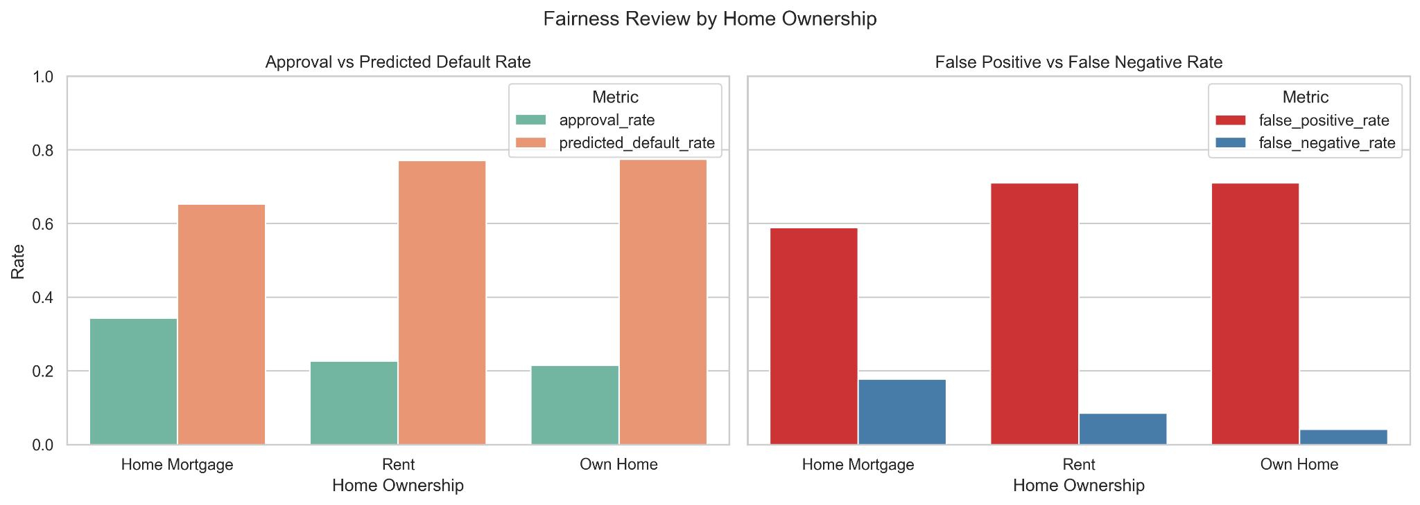

9. Deployment Architecture

The current codebase already demonstrates a functioning prototype through a saved model bundle, a scoring workflow, and a Streamlit interface. However, the production design should be described as a cloud-native target-state architecture rather than as a notebook or dashboard being exposed directly to business users.

A practical target-state design is a containerized credit decisioning platform on Azure. In report language, this can be described as follows:

- Channel layer: loan applications enter through the bank's digital portal or branch workstation.
- API layer: Azure API Management acts as the secure front door for inbound application requests.
- Compute layer: Azure Container Apps hosts stateless Python services for input validation, feature engineering, model scoring, and decision orchestration.
- Model artifact layer: the approved model bundle, preprocessing logic, threshold, and release metadata are stored in Azure Blob Storage or a model registry.
- Decision layer: a policy engine combines PD output with expected-loss rules and business overlays to assign Approve, Manual Review, or Reject / Escalate.
- Workflow layer: borderline or policy-sensitive cases are pushed to a manual-review queue using Azure Service Bus.
- Audit layer: all requests, features, scores, model versions, overrides, and final actions are persisted in Azure SQL Database.
- Batch layer: nightly rescoring and monitoring jobs run on Azure Container Apps Jobs or Azure Functions.
- Observability layer: latency, failures, drift indicators, decision distributions, and fairness metrics are tracked in Azure Monitor and Log Analytics.

The recommended architecture has two operating modes.

Real-time decisioning for new applications

1. Application data is submitted through the bank's digital or branch channel.
2. Azure API Management routes the request to a validation service running on Azure Container Apps.
3. A shared feature-engineering service applies the same deterministic cleaning and derived-feature logic used in model development.
4. A versioned scoring service loads the approved model bundle from Azure Blob Storage and calculates PD.
5. A decision engine applies expected-loss logic, affordability overlays, and policy rules.
6. The outcome is routed to straight-through approval, a manual-review queue, or reject/escalate workflow.
7. All inputs, model version, threshold, output scores, overrides, and final decisions are written to Azure SQL Database for auditability.

Batch portfolio processing

1. Azure Container Apps Jobs or Azure Functions run nightly rescoring for pending applications and selected portfolio segments.
2. Batch outputs support manual-review prioritization, drift reporting, governance dashboards, fairness review, and challenger-model analysis.
3. Aggregate decision summaries and monitoring statistics are persisted for management reporting and model-risk review.

This hybrid architecture is preferable to an all-batch or all-real-time design. New applications need immediate service, while governance, portfolio surveillance, and challenger testing benefit from scheduled batch analytics.

Critical architecture requirements include:

- shared feature logic between training, batch scoring, and real-time scoring
- versioned model bundle and threshold
- blue-green or canary deployment for safe model releases
- explicit decision logging
- manual override capture with reasons
- strict auditability of every production decision
- autoscaling container infrastructure for peak application volume
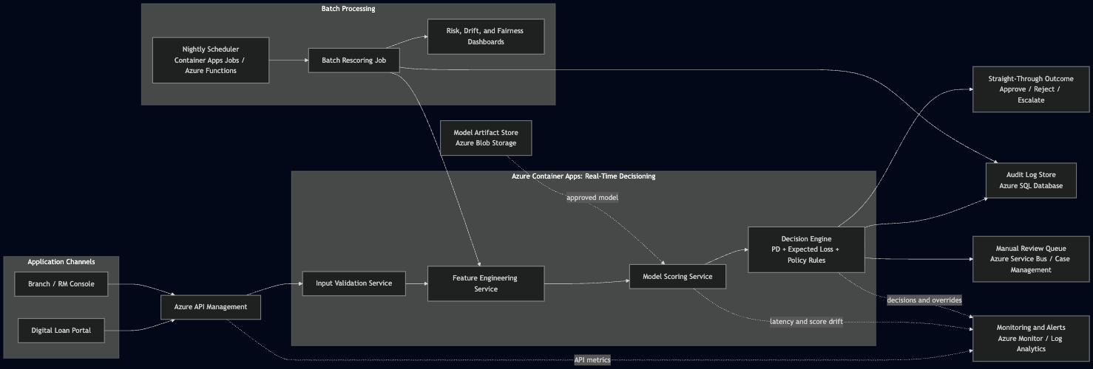

10. Risk Assessment and Mitigation

The solution introduces several important risks. These should be discussed explicitly rather than hidden behind strong prototype results.

Risk | Why It Matters | Mitigation
Overfitting / weak generalization | Train performance is far stronger than test performance, so live results may disappoint. | Stronger regularization, challenger testing, periodic revalidation, and staged deployment.
Process-artifact leakage | loan_amount_placeholder_flag is the strongest feature, suggesting the model may learn operational quirks rather than pure risk. | Fix upstream data capture, test model without artifact-heavy features, and retrain on cleaner data.
Fairness / reputational risk | Home Ownership creates observable group disparities and may proxy socioeconomic patterns. | Prefer conservative feature removal or tighter governance plus continuous fairness monitoring.
Data drift | Missingness, purpose mix, term mix, or portfolio strategy may change over time. | Track input distributions, approval rates, and outcome drift over time.
Policy drift and override inconsistency | Human reviewers may override recommendations unevenly, undermining control discipline. | Require override reasons, second-line review for exceptions, and monthly override audits.
Regulatory model-risk concerns | Credit models are high-stakes and require explainability, auditability, and repeatable controls. | Maintain documentation, model inventory, validation records, and adverse-action explanation readiness.

11. Monitoring and Governance Controls

Monitoring and governance are distinct from risk identification. Risk identifies what can go wrong. Monitoring and governance specify how FBank will detect, challenge, and control those issues over time.

The proposed monitoring framework should operate at multiple cadences:

Daily operational monitoring

- application volumes
- decision-band distribution
- manual-review queue size
- approval rate by channel or product
- system failures and missing-data spikes

Monthly portfolio monitoring

- predicted default rate by segment
- approval rate by segment
- drift in Annual Income, Credit Score, Purpose, and Term
- drift in missingness flags
- placeholder-feature frequency
- fairness gap monitoring on reviewed proxy groups

Quarterly governance monitoring

- override-rate analysis and reviewer consistency
- challenger-model review
- threshold review
- decision-policy review
- issue log and remediation tracking

Annual or trigger-based model review

- full revalidation
- documentation refresh
- performance benchmarking
- fairness re-assessment

Governance should include:

- model ownership in the bank's formal model inventory
- controlled model and threshold versioning
- audit logs for every production decision
- mandatory override reasons
- second-line credit-risk oversight
- compliance review for explanation and customer-treatment issues
- internal audit access to lineage and control evidence
The governance message of this report is that the model should not replace control functions. Instead, it should make control functions more evidence-based.

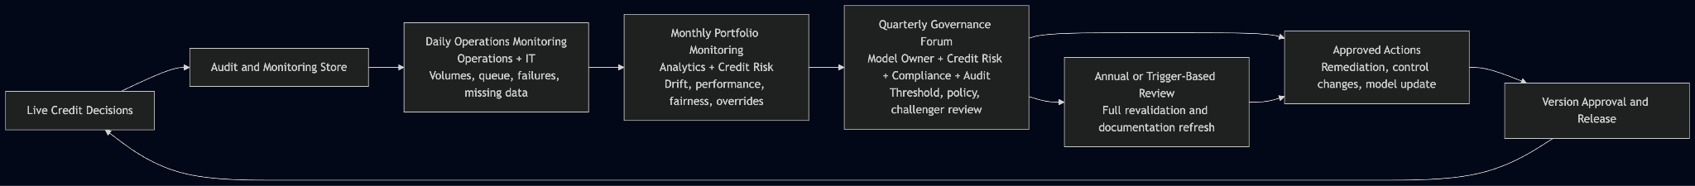
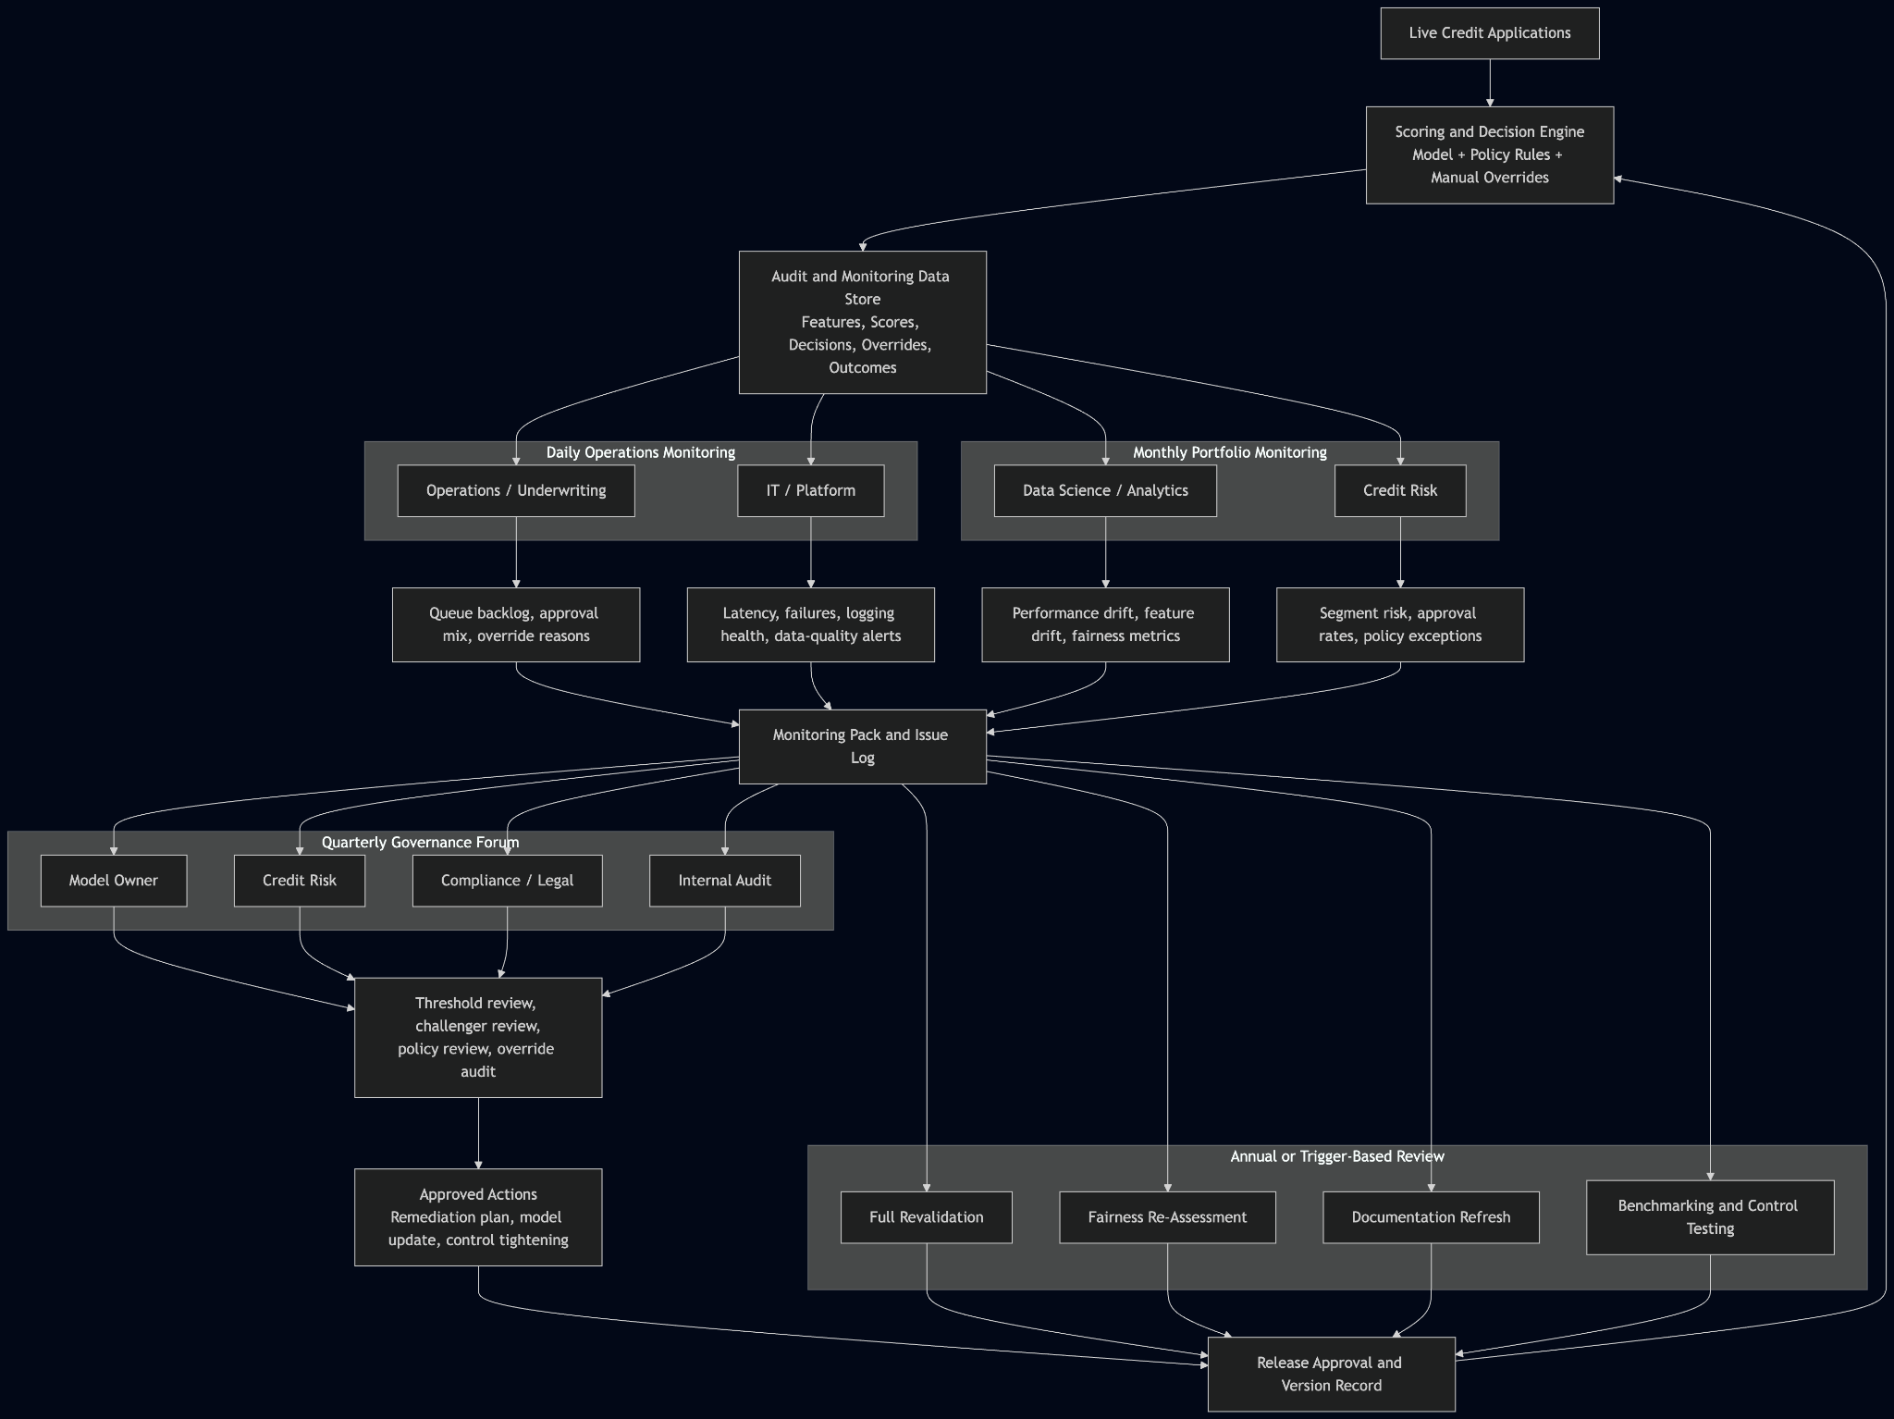

12. Operating Model and Change Management

A successful AI credit system depends on clear ownership, not just strong analytics.

The recommended operating model is:

- Credit Risk: owns policy, threshold approval, override governance, and portfolio risk appetite
- Data Science / Analytics: owns feature logic, model development, challenger testing, and performance analysis
- Operations / Underwriting: owns manual review execution, exception handling, and frontline feedback
- Compliance / Legal: reviews fairness, explanation readiness, and customer-treatment implications
- IT / Platform: owns deployment reliability, logging, model versioning, and system integration
- Internal Audit: reviews control effectiveness and traceability

Change management should be deliberate. A realistic rollout sequence is:

1. Shadow mode: run the model in parallel with the current process without changing decisions
2. Controlled pilot: use the model for decision support in a limited segment
3. Structured override capture: collect reviewer reasons and disagreement patterns
4. Threshold and policy refinement: adjust operating rules before wider rollout
5. Staff training: ensure reviewers understand both the model and the override discipline
6. Governance forum: hold periodic cross-functional recalibration meetings

This approach reduces adoption risk and ensures the model becomes part of a managed process rather than an isolated technical tool.

13. Economic Value Measurement

The bank should measure value along four channels:

1. Reduced bad approvals
Compare expected or realized credit losses before and after adoption.

2. Better risk-tiered routing
Assess whether manual review effort becomes more concentrated in economically meaningful middle-band cases.

3. Lower operating cost
Measure whether straight-through processing increases and unnecessary manual reviews decrease.

4. Faster turnaround time and better customer conversion
Measure approval speed and downstream conversion for low-risk applicants.

A practical value framework is:

Net Value = Credit Loss Savings + Manual Processing Savings + Conversion/Uplift Benefits - Build, Run, and Governance Costs

Where:

- Credit Loss Savings can be estimated from differences in bad-approval rates and loss severity
- Manual Processing Savings can be estimated as:
(baseline manual reviews - new manual reviews) × cost per review
- Conversion/Uplift Benefits should only be added when the bank has real funnel and pricing data
- Build, Run, and Governance Costs should include model maintenance, infrastructure, validation, monitoring, and review overhead

14. Conclusion

This project demonstrates that FBank can move from a hybrid manual/rule-based process toward a more disciplined AI-supported credit decision system.
The technical results show that the model can rank risk meaningfully and support loss-aware decision banding. The business results show that the system can segment new applications into clear operational actions. The governance results show that fairness and process-artifact concerns are visible and manageable rather than hidden.

The correct final recommendation is not to deploy the prototype unchanged. It is to treat the current solution as a strong proof of concept and move toward a more conservative production version with cleaner upstream data, tighter feature governance, explicit override discipline, and formal monitoring. Framed that way, the project is not only technically credible, but also commercially and operationally responsible.

15. Appendix

# Appendix A. Key Assumptions

- PD is the model-predicted default probability.
- EAD is approximated by the cleaned current loan amount.
- LGD is fixed at 45%.
- Expected loss is modeled as PD × LGD × EAD.
- Revenue, margin, fees, and collections data are unavailable, so profit is not estimated directly.
- Home Ownership is used as an internal proxy fairness review field, not a legal fairness declaration.

# Appendix B. Preprocessing Rules

- Normalize Have Mortgage to Home Mortgage
- Rescale credit scores above 850 by dividing by 10
- Mask Current Loan Amount = 99,999,999 and preserve it through a placeholder flag
- Convert Years in current job into job_tenure_years
- Add missingness flags for income, credit score, job tenure, and delinquency history
- Median-impute selected numeric fields using train-only statistics
- Engineer:
- monthly_dti
- credit_utilization_proxy
- loan_to_income_ratio

# Appendix C. Detailed Final Model Metrics

Split | ROC-AUC | Precision | Recall | F1
Train | 0.9999 | 0.5130 | 1.0000 | 0.6781
Validation | 0.6835 | 0.3611 | 0.8738 | 0.5111
Test | 0.6778 | 0.3454 | 0.8738 | 0.4951

Selected final XGBoost tuning parameters

- n_estimators = 200
- max_depth = 7
- learning_rate = 0.1
- min_child_weight = 1
- subsample = 0.8
- colsample_bytree = 1.0
- final threshold = 0.1019

